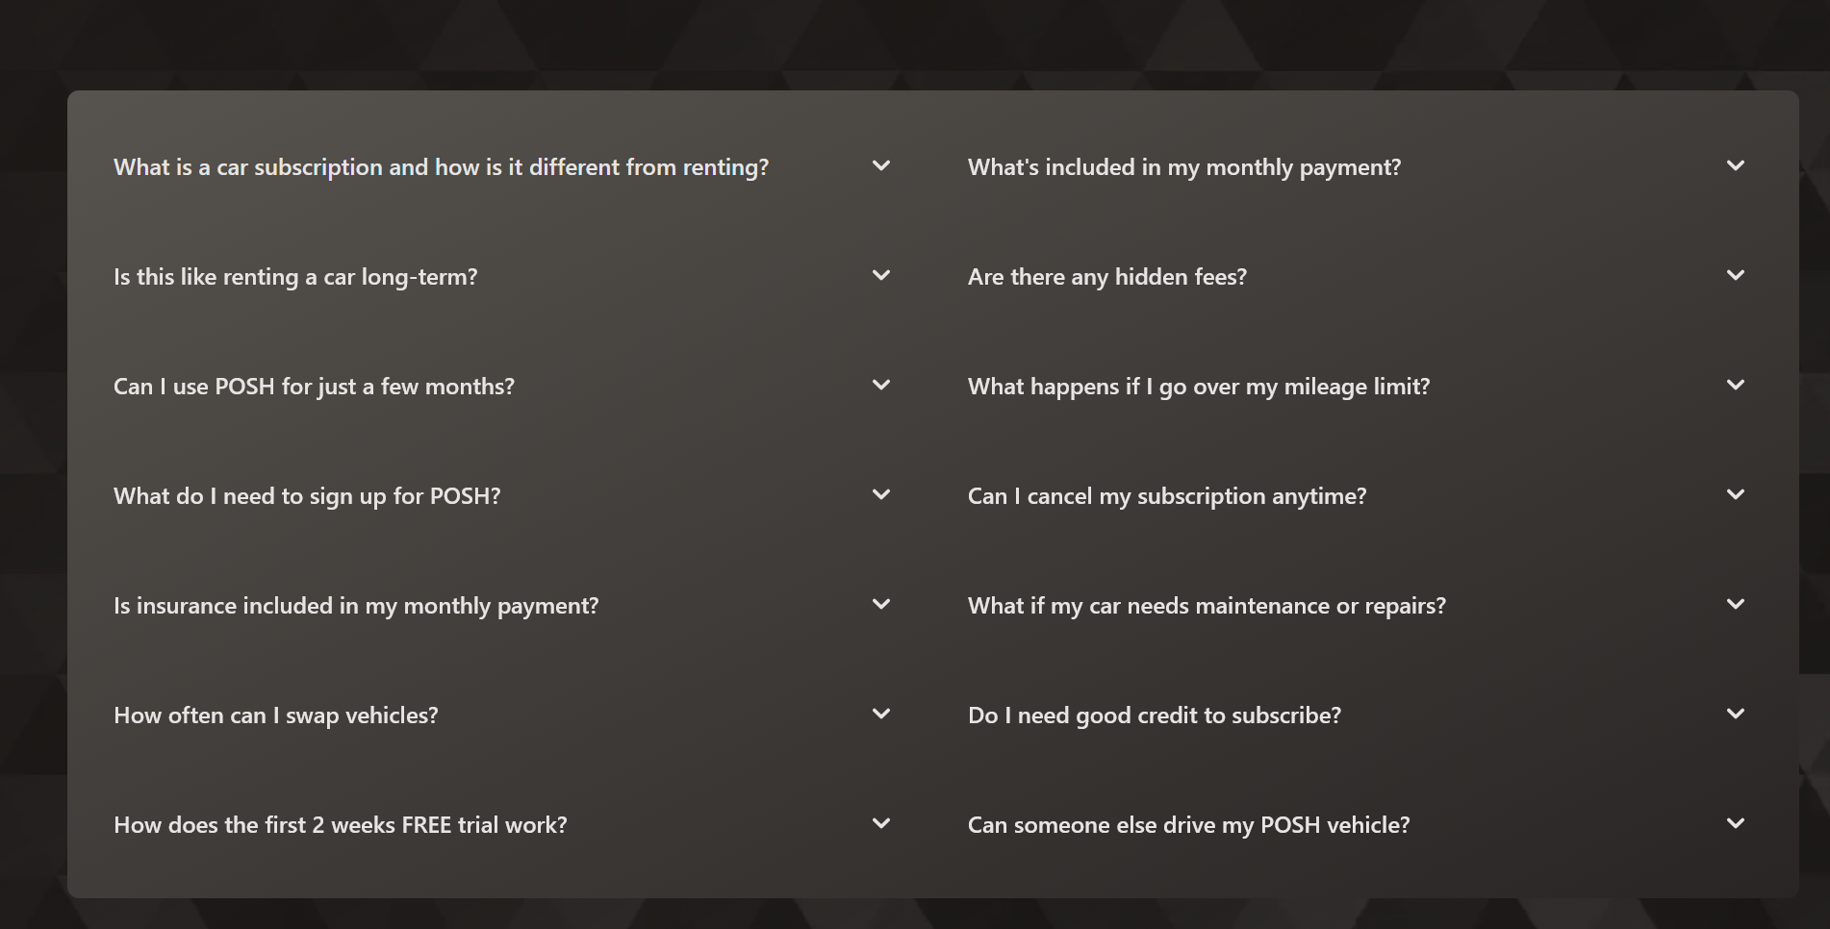
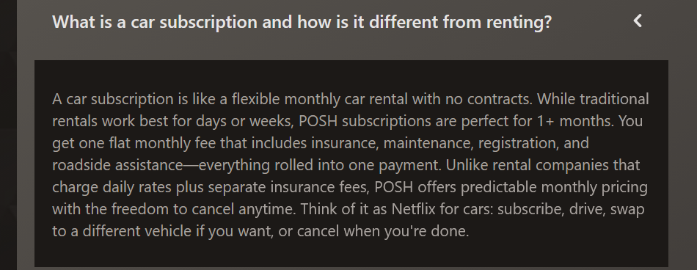
Instead let’s change this to:
How is membership at Zipsters different than buying a car from a dealer?

With a Zipsters membership you have the ability to change cars anytime you choose unlike buying a car from a dealer . When you buy a car from a dealer there is a payoff on the car that you purchase and if you try to trade that car in for another before the car is paid off you may find out that the payoff on the car is higher than the value of the car making it difficult to change cars. With Zipsters there is no payoff to worry about so you can change vehicles as much as you like.

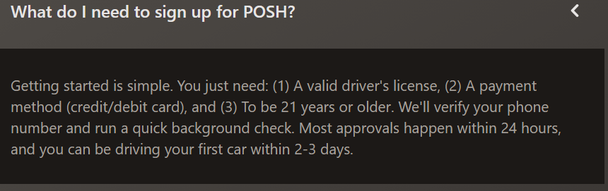
Instead let’s do this:

What do I need to qualify for Zipsters membership?

All that is needed to become a member. 1.) valid driver’s license. 2.) full coverage insurance. THERE IS NO CREDIT CHECKS OR EMPLOYMENT VERIFICATION REQUIRED!!

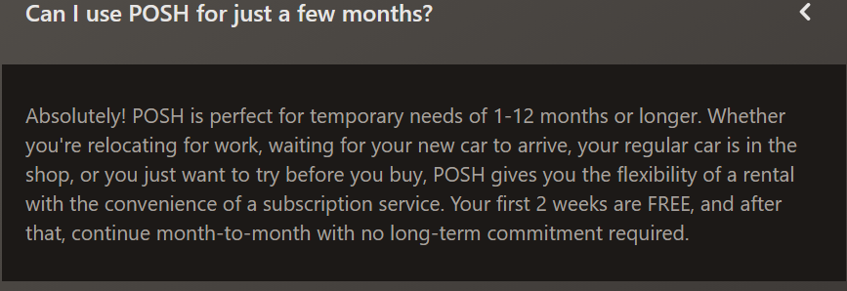
Instead let’s do this.
Can I use my membership short term?
Yes, just simply return the vehicle once your done driving. It’s that simple.

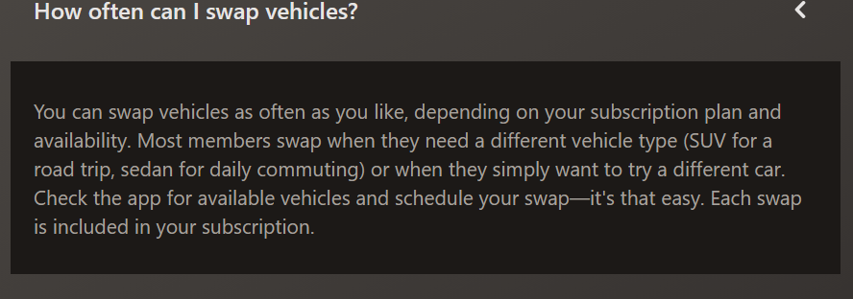
Instead let’s do this:
How often can I swap vehicles?
You can swap vehicles as much as you like at no additional cost provided the vehicle you would like to swap to qualifies for the same membership plan that you have. If the vehicle that you would like to swap for qualifies for a different membership plan then there may be a slight up charge. Your representative can go into more detail.

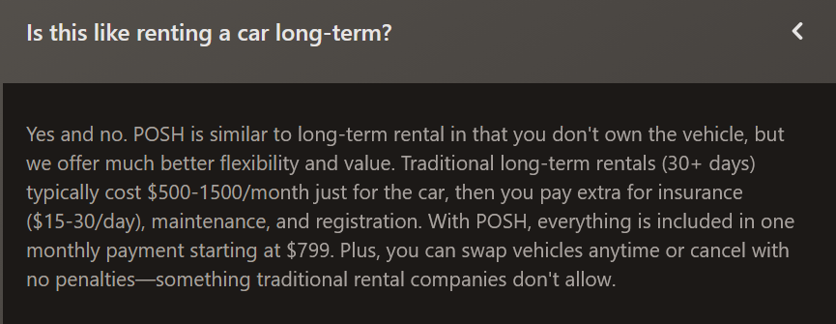
Just get rid of this one.
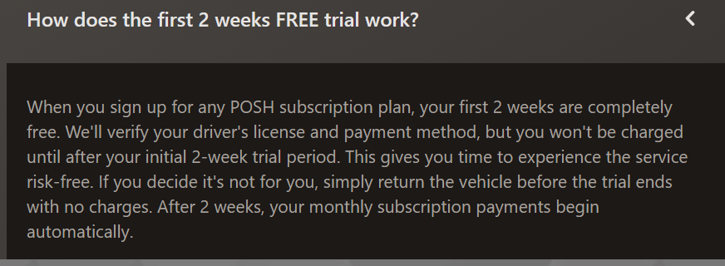
Just get rid of this one

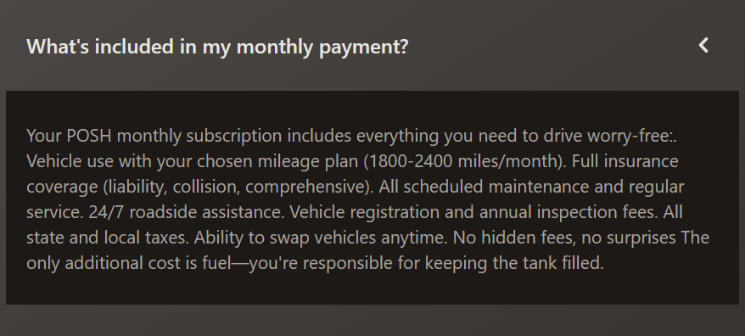
Instead let’s do this:
How do I pay for my membership?
Membership dues are paid on a weekly basis. We accept payment by Zelle for ease to our members. Ask a representative for details.

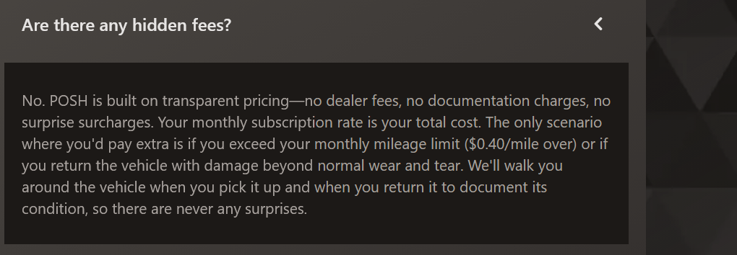
Instead let’s do this;
Are there any other costs?
The only costs you will have are initial deposit, due payments and Insurance.

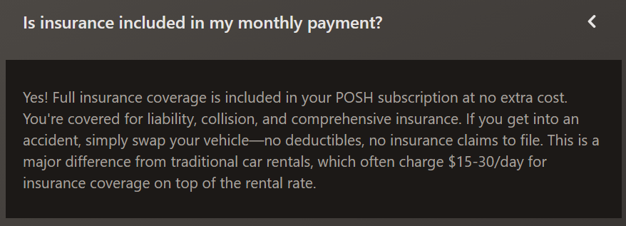
Instead let’s do this;
Can I get insurance through Zipsters?
In some cases yes, we can get you a quote through our insurance company. Rates will depend on members driving record.

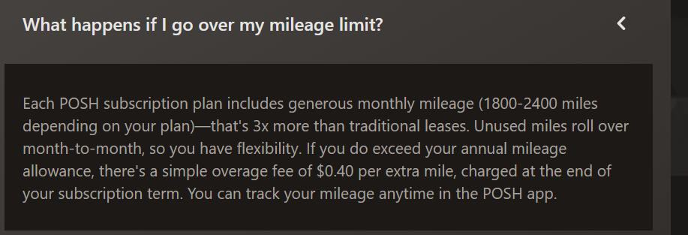
Are there any restrictions regarding my membership with Zipsters?
If a member wants to alter anything cosmetic or mechanical to their vehicle, they must notify Zipsters prior to changes for approval. Other than that, there are no other restrictions.

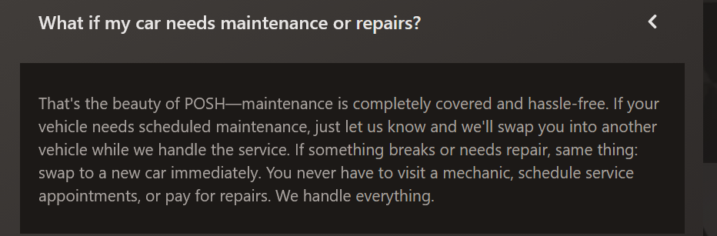
Instead let’s use this;
Is the member responsible for maintenance and or repairs?
Zipsters membership include all scheduled maintenance ex; oil changes. Repair programs are available for your membership. One of our representatives will be happy to explain different options available.


Instead let’s use this;
Can I cancel my membership anytime?
Yes, Membership gives you the freedom to cancel whenever you choose, simply bring the vehicle back to a Zipsters location.

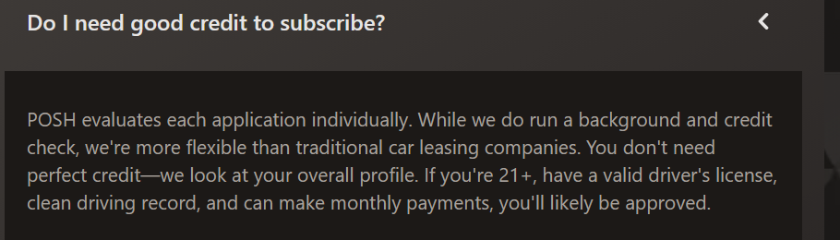
Just get rid of this.

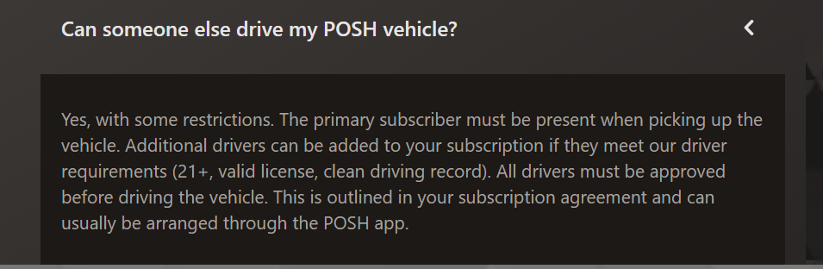
Instead use this:
Can anyone else drive the car?
As long as the other person is listed on your insurance as a driver then yes, they can drive.

